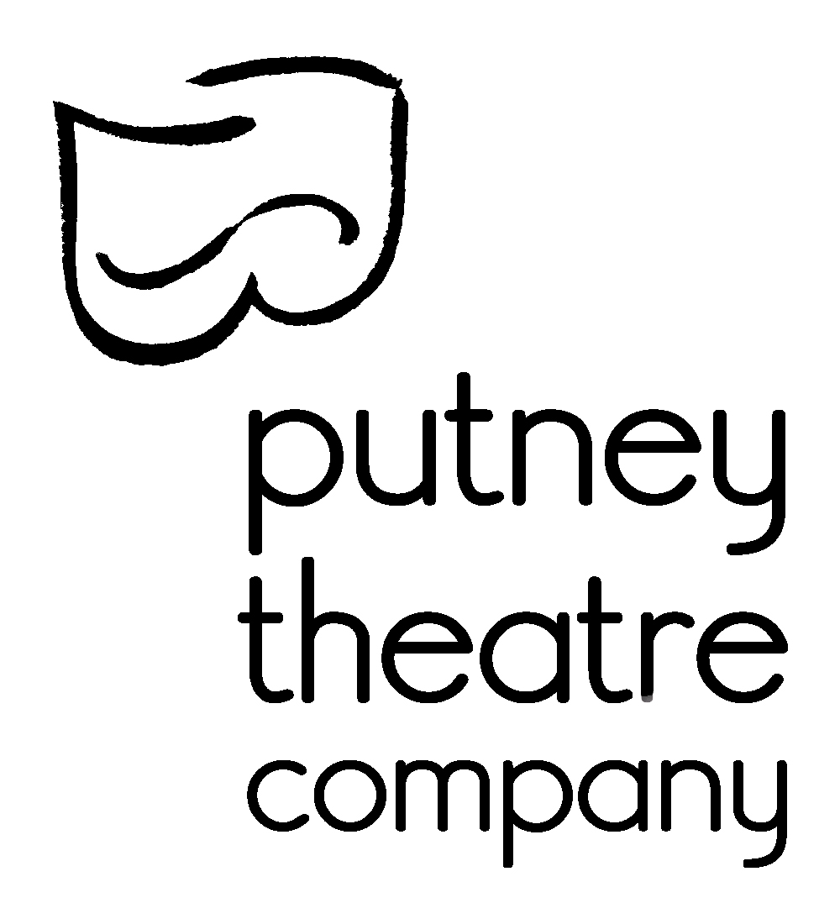
Audition Form

Agatha Christie’s The Hollow

Performance Dates: 21st - 25th April 2020 @ 7.45pm
25th April 2020 @ 3pm

Rehearsal Period:
Rehearsals will take place 2 -3 nights a week Monday to Friday, although you may not always be called. There will also be a 11 - 5 rehearsal on most Sundays. For the fortnight before the performances you should be prepared to be called more regularly.

Please Note:
This is an amateur production. You do not need to be a member of PTC to audition but actors and crew will need to become members for £20 a year if they take part in the show. A £20 show fee will also need to be paid by all actors in the production. We’d encourage you to become a member of PTC anyway even if not cast.

Would you like to become a member of PTC anyway? Yes No

Please write in BLOCK CAPITALS. If we can’t read your writing we can’t contact you!

Name: …………………………………………………………………

Email: …………………………………………………………………

Tel No: …………………………………………………………………

Characters Auditioning For (Circle your Choice):

As Cast Henrietta Midge Lucy Gerda

John Edward Henry Inspector Sergeant

Vernon Gudgeon

Dates Unavailable for Rehearsal:
If you are away on holiday or have any dates you are unavailable please make us aware now. (If you don’t tell us until after casting then we may be forced to change our minds.)

…………………………………………………………………………………………

…………………………………………………………………………………………

…………………………………………………………………………………………

Previous Experience
Please tell us briefly about the last three productions you were involved with or relevant experience if you haven’t recently been in a production.

…………………………………………………………………………………………

…………………………………………………………………………………………

…………………………………………………………………………………………

